Table of Contents

List of tables 2

Chapter 1 3

1.1 Introduction 3

1.2 Justification for project 3

1.2.1 Background of project 3

1.2.2 Problem Statement 3

1.3 Description of project 3

1.3.1 Features 4

Chapter 2 4

2.1 Scope and limitation of project 4

2.2 Aim 4

2.3 Objective 4

Chapter 3 6

3.1 Development Methodology 6

3.2 Design pattern 7

3.3 System Architecture 7

Chapter 4 8

Work Breakdown Structure (WBS) 8

4.1 Work Breakdown Structure 8

4.2 Milestones 9

4.4 Gantt chart 10

Chapter 5 12

5.1 Risk Management 12

5.2 Lifecycle of risk management 12

Chapter 6 14

Configuration management 14

Conclusion 14

References 15

# List of tables

Figure 1:Waterfall lifecycle 5

Figure 2: WBS structure 7

Figure 3: Milestone table 8

Figure 4: Schedule 9

Figure 5:Gantt chart 11

Figure 6:Schedule 2 11

Figure 7:Risk management 11

Figure 8:Configuration management 13

# Chapter 1

## 1.1 Introduction

Online food home delivery system is web application which helps to create online food order and delivery pathway between the customers and restaurant. With the increasing popularity of the food home delivery services this project may be and update or option to the traditional telephone food order system. Much like [ordering consumer goods online](https://en.wikipedia.org/wiki/Online_Shop), many of these services allow customers to keep accounts with them in order to make frequent ordering convenient. A customer will search for a favorite restaurant, usually filtered via [type of cuisine](https://en.wikipedia.org/wiki/List_of_cuisines) and choose from available items, and choose delivery or pick-up.

This project intends to maximize the use of latest technology and provide the quick and convenient services to the customer.

## 1.2 Justification for project

I want to develop online food home delivery system which is trending now so that people can order foods they want from different restaurants online at one order. via internet connection. This web application must be fast responsive with high performance which should provide smooth navigation experience to the user with the best food services in efficient cost.

## 1.2.1 Background of project

There are many types of online food home delivery website that exist already. Many of the features can be similar to the web-application found in the market. The main objective of this project is to provide high quality user experience. This application will be provided to some people for the purpose of testing and also getting the feedback of the user.

## 1.2.2 Problem Statement

This project is to create a chat web application that focus on the current market i.e. Nepal market. Nepali market will be the main focus as a decent web application are usually developed outside the market. This application will be improved version of the current application found in the market.

## 1.3 Description of project

This project is to create a web based online food home delivery application with a server and users to enable order processing and food delivery between the customer and the different restaurant will to provide the service through the portal. It makes both the customer and the restaurants to make a transaction between each other.

All the person with the basic knowledge of computer and web will feel easy to use this portal.

## 1.3.1 Features

* User can order foods from any place
* User can provide feedback
* Foods and services of different restaurant can be order at one time
* Restaurant can upload their menu in the portal
* Cash on delivery and bill generation
* Control multiple orders
* Control staff and their shifting
* Customer support
* Delivery scheduling
* User history can be viewed
* Restaurant can see reviews received from the food

# Chapter 2

## 2.1 Scope and limitation of project

1. This application will be a pathway between the customer and restaurant for the order and delivery of different services
2. Different food items can be added in one cart
3. To add and remove different orders in the cart
4. To provide user-friendly experience while running this application
5. Project may or may not be used to make communication between two party.
6. This web application may not be compatible to all the devices.

## 2.2 Aim

* To provide fast and convenient food order and delivery system for both the customer and restaurant
* To provide customer the facility of order different items of food from different restaurant at one time
* To provide restaurant the online portal to gain the online customer and cost-efficient food home delivery

## 2.3 Objective

* To analysis the current problem faced and provide better solution and implementation of the system.
* To design a new web-application with user friendly environment with different features.
* To test the web-application being designed in order to increase the efficiency and performance of web-application.
* Each steps during the development phase must be tracked.
* To document the all the features and report of the web-application.

# Chapter 3

## 3.1 Development Methodology

For the development of this project I’ll be using waterfall module as it is the traditional method for the system development. This method is non-repetitive, non-iterative and sequential approach for the project development. This methodology is simple and easy to understand and also implement it. In this methodology every steps should be completed before going through next process. Waterfall methodology consist of different stage like Analysis, Design, Implementation, Testing, Deployment and Maintenance. Every steps must be completed in the following order before going to next step.

**Advantage of Waterfall method**

* This methodology is easy/simple to use
* It is easy to implement
* This mythology is flexible for small project
* Each steps should be completed before going through next stage. So, it provides certainty that every steps are completed

**Disadvantage of Waterfall method**

* This methodology is non-iterative. So, returning to previous stage might be difficult.
* It is not applicable for large project.
* There is less involvement of user.
* High chance of risk and uncertainty.

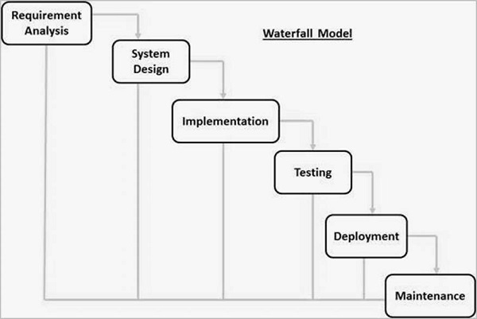

Figure 1:Waterfall lifecycle

## 3.2 Design pattern

Design pattern is optimized, reusable solution of programming problems. Design pattern is not a class or a library that we can simply plug into our system. It’s not a language-specific either. It helps to speed up the development process of the software. There are three main types of design pattern i.e. Structural, Behavioral and Creational pattern. Those pattern are divided into sub pattern. (www.tutorialspoint.com, 2018)

For the development of this project I choose MVC (Module View Controller) design patterns. This pattern separate applications into three Module, View and Controller. Module represent an object. It also has logical to update controller if its data is change. View contain the visual of the data that module contain. Controller acts on both module and view. It controls the data flow into model object and updates.

## 3.3 System Architecture

Three-tier architecture is a client–server software architecture pattern in which consists of presentation, Application and Data tier. . (Software Testing Material, 2018)

* **Presentation tier:**

The part of the application which is visible to the user; it enables the input of requirements and the presentation of results.

* + **Application tire:**

The middle layer of the model, it assures the calculations and operations performed between input-output requirements and data.

* + - **Data tire:**

The lowest layer of the model, it ensures all operations with [data](https://managementmania.com/en/data), i.e. [database management system](https://managementmania.com/en/dbms-database-management-system) and basic data-base operations for functional storage, selection, aggregation, processing, integrity, and data audit.

# Chapter 4

# Work Breakdown Structure (WBS)

## 4.1 Work Breakdown Structure

WBS helps to view structure of the project. It helps for planning and execution of the project very effectively. It depicts when to start project, how to start project, and how project is controlled. Work Breakdown Structure can be performed using various method like Time estimation, Milestones, and Scheduling or Gantt chart (Workbreakdownstructure.com, 2018

Figure 2: WBS structure

## 4.2 Milestones

Milestone is a fixed point in a project life cycle where progress can be tracked within various time frame. For my project, I’ll be submitting my proposal on January 4. Analysis and design specification on 5 august and 4 September, 2018 respectively. Testing will be finished in 4 October. And final report will be finished in 17 October, which is the deadline for projects.

The table for the milestone is below:

|  |  |  |  |
| --- | --- | --- | --- |
| **S. N** | **Task name** | **Days** | **Date** |
|  |  |  |  |
| 1 | **Project Management**  Risk Management  WBS  Configuration Management  Proposal Submission | **14**  3 days  3 days  6 days  2 day | **January 04,2019** |
| 2 | **Analysis**  Requirements  Use Case  Architecture [Initial Class Diagram]  Analysis Specification | **25**  5  5  7  8 | **January 29,2019** |
| 3 | **Design**  Structural model [Class Diagram]  Behavioural Model  UI Design  Database Design[ER diagram][Data-Dictionary] | **29**  6  5  8  10 | **Feb 27,2019** |
| 4 | **Implementation**  Build Database  Coding | **31**  14  17 | **March 30,2019** |
| 5 | **Testing**  Unit Testing  Integration testing  Black box testing  White box testing | **11**  4  2  3  2 | **April 10, 2018** |
| 6 | **Deployment**  User Training  Final Report | **10**  4  6 | **April 20, 2019** |

Figure 3: Milestone table

With the help of milestone, we can keep track of project about the deadline of the project.

What need be completed?

What expect of the project is completed?

When will the project be completed.

Now I have to build project on the basis of the milestone provided above. All the sub heading of the milestone must be started and completed according to the date provided so that the project can be completed without any issue.

## 4.4 Gantt chart

The Gantt chart for the designed schedule has been given below designed via Projectlibre. Gantt chart helps to assess how long a project should take and also determine the resources needed and make a plan in order to accomplish the tasks.

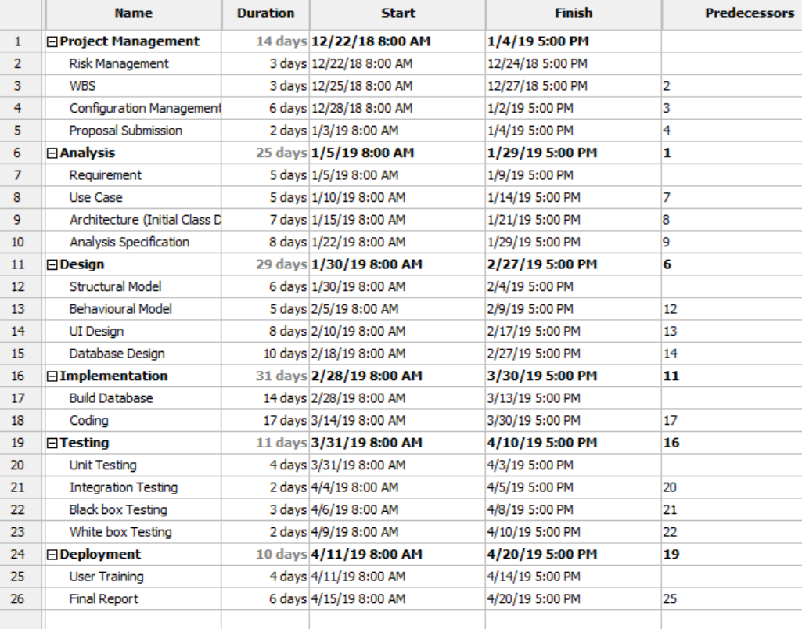

Figure 4: Schedule

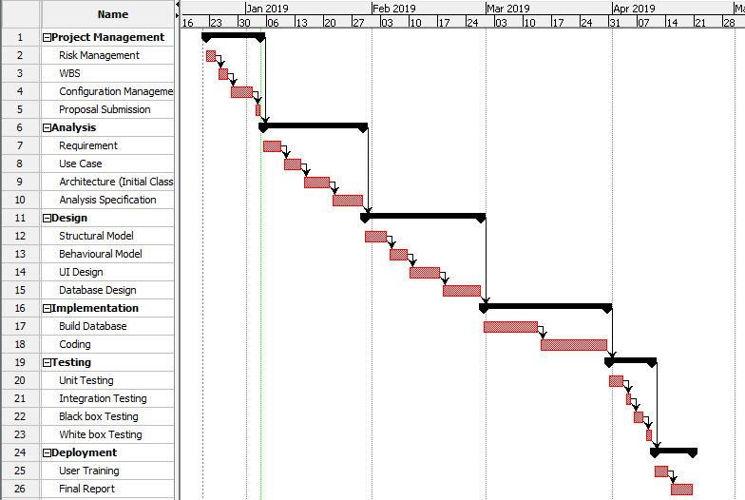

Figure 5:Gantt chart

# 

# Chapter 5

## 5.1 Risk Management

Risk management is a potential problem or expectation of loss that may occur in future or it may not. It helps to identify the possible problem that may hamper the development of software. Risk management can be caused due to lack of information, control or time. It helps us to calculate the risk to minimize loss of time, money and effort.

## 5.2 Lifecycle of risk management

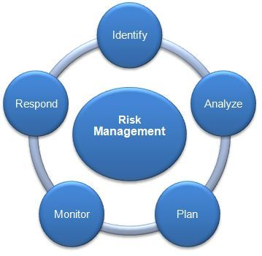

Figure 7:Risk management

* At beginning we should identify lifecycle of risk management.
* How is the system going to effected? should be analysis.
* Planning should be briefly explained.
* Risk should be monitored.

The likelihood table and values are represented in the table below. Likelihood which is low or may happen less has 1, medium has 2 and the likelihood that may occur many times is 3.

Table 1: Likelihood

|  |  |
| --- | --- |
| **Likelihood** | **Value** |
| Low | 1 |
| Medium | 2 |
| High | 3 |

Now there is table of consequence and their value. Very low consequence has the value of 1, low has 2, medium has 3, High has 4 and Very High has 5.

Table 2:Consequence

|  |  |
| --- | --- |
| **Consequence** | **Value** |
| Very low | 1 |
| Low | 2 |
| Medium | 3 |
| High | 4 |
| Very High | 5 |

Table 3:Consequence

In order to know the risk management, I have selected some possible risk that may occur while developing the application. Those risk will be listed and the values of its consequence and likelihood will be provided. After that, Impact will be calculated based on the

**(Impact = Consequence * Likelihood).** The risk management table for this application has been provided below with the short description of necessary action to be implemented.

Table 4:Risk Management

|  |  |  |  |  |  |
| --- | --- | --- | --- | --- | --- |
| **S. No** | **Risk** | **Likelihood** | **Consequence** | **Impact** | **Action** |
| 1 | Time Constraint | 2 | 4 | 8 | Complete each step to move forward |
| 2 | Hard disk Corruption | 3 | 3 | 9 | Use cloud i.e. Google drive for data backup |
| 3 | Data theft | 3 | 4 | 12 | Firewall, antiviruses should be installed and updated |
| 4 | Lack of training | 4 | 4 | 16 | Different kind of training and workshop should be conducted. |
| 5 | Natural disaster | 2 | 3 | 2 | All the data must be backup. |
| 6 | Cost Risk | 2 | 4 | 8 | Budget allocation may not be sufficient. |

# Chapter 6

## Configuration management

Configuration management is a system engineering process for establishing and maintaining consistency of a product’s performance, function, and physical attributes with its requirements, design, and operational information throughout life. The items that make the system is determined by the configuration management. This may include hardware, third-party software, source code and documentation. It ensures the design and the operational sate of the system and make sure the system is well known.

The major process that involve the configuration management are:

* Planning and the management
* Identification
* Control
* Status counting
* Verification and audit

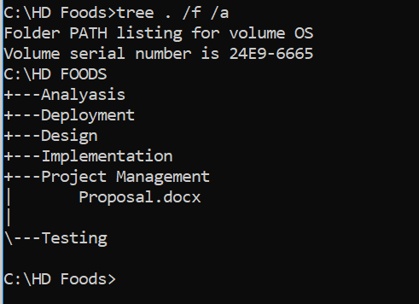

Figure 8:Configuration management

# Conclusion

There is always a room for improvement in the web development. Online food home delivery system helps to make the home delivery fast and overcome the inefficiency of the traditional telephone order and delivery system. For this project, proper planning, scheduling was done, and the time estimation was done accordingly. This project may help to establish the automated communication regarding the order and delivery between both the customer and the restaurant. After analyzing suitable development tools, design patterns and using techniques such as estimation and WBS, an overview of what needs to be done and time allocation for certain tasks is recognized.

Hence, the project is ready to enter its next phase of analysis specification.

# References

Software Testing Material. (2019). *Software Architecture: One-Tier, Two-Tier, Three Tier, N Tier*. [online] Available at: https://www.softwaretestingmaterial.com/software-architecture/ [Accessed 4 Jan. 2019].

Workbreakdownstructure.com. (2019). *What is a Work Breakdown Structure - Workbreakdownstructure.com*. [online] Available at: http://www.workbreakdownstructure.com/ [Accessed 4 Jan. 2019].

www.tutorialspoint.com. (2019). *Design Pattern Overview*. [online] Available at: https://www.tutorialspoint.com/design_pattern/design_pattern_overview.htm [Accessed 4 Jan. 2019].